GameOn Game Hub
ANALYSIS AND DESIGN DOCUMENT

Group 4
Zainab Akubat
Richard Hall
Muhammad Mozzam Khan

Contents
Contents 2
Introduction 4
System Architecture 4
System Overview 4
Architectural Design 4
Decomposition Description 5
Design Rationale 5
Human Interface Design 5
registration 6
INPUT & OUTPUT 7
Actions 7
Pre and Post Conditions 7
Validation 8
LOGIN 8
INPUT & OUTPUT 8
Actions 9
Pre and Post Conditions 9
Validation 9
CHANGE PASSWORD 10
INPUT & OUTPUT 10
Actions 10
Pre and Post Conditions 11
Validation 11
Component Design 12
Entities 13
Data Design 13
Data Description 13
Registration / Authentication 13
DATABASE Dictionary / SCHEMA 14
Registration / Authentication 15
Full DAtabase Model 16
Requirements Matrix 17
Appendices 17

Introduction
- Purpose:
  - Currently, a gamer has no centralized location to get all of their gaming needs.
  - Our software will provide a “one stop shop.” Gamers will no longer need to roam the internet hoping to find the relevant information they require for their game of choice.
  - Our objective is to offer competition to sites such as Steam and Origin. We plan on optimizing our loading times to less than one second per page load. We plan on accomplishing this goal by providing simple, yet flamboyant layouts, based on PHP, that quickly inform our customers of exactly what they need to know, whenever they need to know it.
- Scope:
  - Our site will generate a custom web experience based on the database management software PHP. A user will request information that our database will return, tailored to the user.
  - Our software will allow users to search for games, read reviews, read game news, subscribe to newsletters, sort games by popular headings such as ratings, genre, platform, top selling, and top fan favorites.
  - Our software will provide a closed community of gamers without the fear of flaming or spam. This will be moderated by our community log in membership requirement.
  - A benefit of our software is that we strive to build a community of gamers who share in the gaming experience, building a network of trusted peers within the gaming community.
- Definitions, acronyms and abbreviations:
Admin: An elevated system user who has extended privileges including viewing question metadata, creating other admins, answering forum questions, adding definitions to games in the database, and editing customer questions in the forum.
Customer: any individual who registers on “GameOn” is considered a customer.
Database: our continuously updated reservoir of knowledge, in digital form, that a user may access.
Gamer: an all-inclusive term that simply means any individual interested in learning more about popular video games.
PHP: is a server-side scripting language designed for web development but also used as a general-purpose programming language.

System Architecture

System Overview
Our site will be designed in a way that it will be user-friendly so users do have to stay confused on what they system is trying to do. Our system will have a registration and log-in page so that users can register as well as sign up to receive newsletters. There will be a search bar to search for games which will bring up information about the game and other things related to the game. The modules we will be displaying are games catalog, new, and newsletter. Our system will strive to meet the standards of our users.

Architectural Design
The modules that will be displayed on out site will be Games Catalog, news, and newsletter. The relationship between the news and newsletter are similar. The user will subscribe to the newsletter if they want to receive newsletters from the site. If they agree upon the decision the admin will send newsletters to its registered users. The user will be able to see news as well in their emails sent by the admin. Once they register into the site they will be able to browse the games catalog and be able to see what they desire about the game they chose to search.

Decomposition Description
So our system basically has three data part, the main system data, user data and the business data. The user data has two accesses the admin and the customer. Both admin and the customer can accesses services such as viewing the games catalog, reading the newsletter, and reading the news. The newsletter portion for the user can be accessed via email only if the user is subscribed to receiving emails. The business data is all the data in the site and it is stored in the main compartment which is the system data.
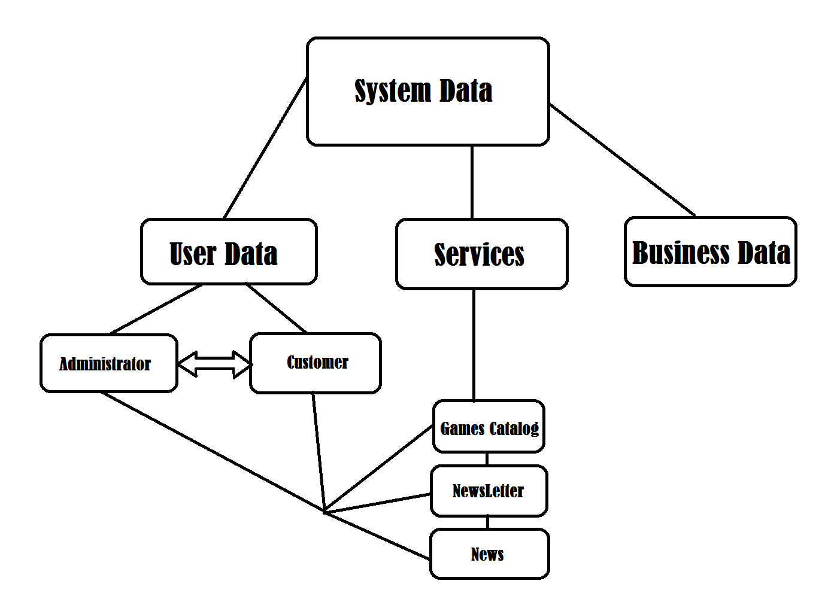

Design Rationale
The critical issues in our site will be hardware limitations. Our site will be governed by the speed of the internet connection of the user. Our application will be hosted on a cloud. Our cloud servers contain redundant power supplies as well as redundant data, therefore our application will reside at level 3.

HUMAN INTERFACE DESIGN

registration
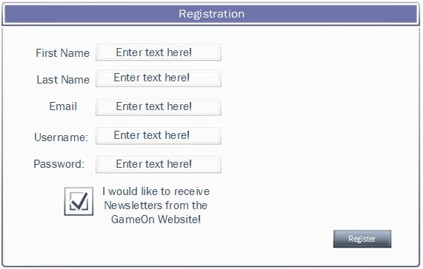
The registration page will allow new users to register with the system as well as having the option to subscribe to Newsletters from GameOn. The user must enter all fields before choosing the register button.

INPUT & OUTPUT

Input:
- First Name: String representing the first name of user. Minimum of 1 and maximum of 30 characters.
- Last Name: String representing last name of user. Min 1 and maximum 30 characters.
- Email: User’s email address used for communication and receiving Newsletters if chosen. Should match standard email pattern “name@server.com”. Minimum of 10 characters, maximum of 30 characters.
- Username: string representing the username can be a minimum of 3 characters and a maximum length of 20.
- Password: Also a string. Must be a minimum of 10 characters and a maximum of 20. Must contain one capital letter.
- Check box: The user will leave the check box marked if they want to receive Newsletters. If the user does not want to receive Newsletters they will uncheck the check box.

Output:
Upon successful creation of user, the system will return success and display a message saying, “Thank You”. In addition, if the data entered is not valid, the system will be failed and will notify the user. The user will correct the errors and click Register once again.
Possible messages:
Successful: “Thank You”
Failed: “There is an error with your information. Please review the fields highlighted in red and re-enter the information”.

Actions
Upon submitting the form, the system will validate that all required fields have input, and that each field matches the required data in the required format.
If the validation is successful, the system will run a query to store the user’s information in the database.
If the validation failed, the system will abort transaction and return an error message for each invalid field.

Pre and Post Conditions
Pre-conditions: User has not registered with the system already. The system should validate that the email and username are unique within the stored user values.
Post-conditions: User record is stored successfully. A user session is created.

Validation
The following validations will be performed on the submitted data:
- First Name, Last Name: fields must be at least the minimum specified length and no more than the maximum length.
- Username: must be unique.
- Email: must be unique and must meet standard email address format.
- Password: Must meet standard strong password policy. The password must be stored using a secure mechanism that will prevent unauthorized access. All passwords will be hashed and stored as such in the database.

create newsletter
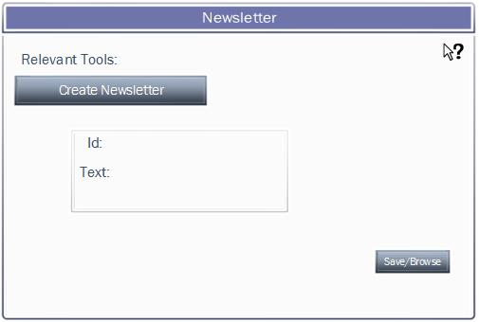
The Newsletter page will allow the administrator to create a new Newsletter and save it, so the administrator can send out emails to registered users.

INPUT & OUTPUT

Input:
- Title: The title of the Newsletter or title of the game.
- Text: Information about the Newsletter and about the game that is being talked about.

Output:
The Newsletter will be saved to the database as well as where the admin wants to specifically save it.

Actions
Once the admin saves the Newsletter, it will be saved to the database as well as wherever they wish to save it. Once the Newsletter is saved, the admin will be able to send out emails to the users that are registered to receive Newsletters.

Pre and Post Conditions
Pre-conditions: The admin must have access to create Newsletters, as well as be able to look at the database where the users and their names are listed to receive Newsletters.
Post-conditions: If the admin correctly makes the Newsletter, they will be able to send out emails to registered users.

Validation
The ID of the Newsletter must be a new number in order to have access to sending out emails to registered users.

EDIT NEWSLETTER
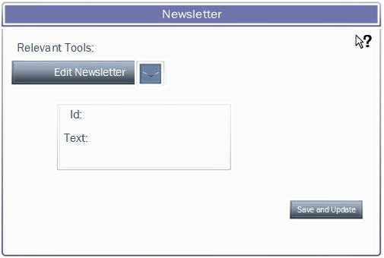
The Newsletter page will allow the administrator to edit the Newsletter of their choice as well as save and update it.

INPUT & OUTPUT

Input:
- Title: Select the Newsletter from the drop down arrow, and select the Newsletter you want to edit.

Output:
The system will place the original Newsletter with the new Newsletter and save it to the database.

Actions

Once the admin saves and updates the Newsletter, it will be saved to the database. Once the Newsletter is saved, the admin will be able to send out emails to the users that are registered to receive Newsletters.

Pre and Post Conditions
Pre-conditions: Admin has access to edit Newsletters.
Post-conditions: Successful edit, will replace the old Newsletter with the new Newsletter and save it to the database. Registered users will receive the edited version of the Newsletter.

Validation
Based on successful completion of editing Newsletter, the old Newsletter will be replaced with the new Newsletter, as well as users will be notified of the edited version.

PREVIEW NEWSLETTER
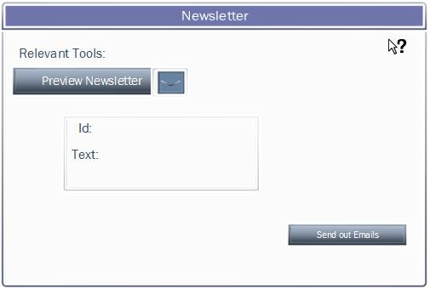
The Newsletter page will allow the administrator to preview the Newsletter of their choice before sending out emails.

INPUT & OUTPUT

Input:
- Title: Select the Newsletter from the drop down arrow, and select the Newsletter you want to preview.

Output:
The admin will be able to select the email list and send out emails.

Actions

Once the admin selects a Newsletter from the drop down list, the database will be searched and the Newsletter will be displayed. Once the admin previews the Newsletter, they will select the send out emails tab, and send out emails to registered users.

Pre and Post Conditions
Pre-conditions: The admin has access to preview the Newsletters.
Post-conditions: Successful submission of Newsletter will allow the admin to preview the final product before sending out emails to registered users.

Validation
Based on successful completion of previewing Newsletter, the admin will be able to send out emails to the registered users.

Component Design
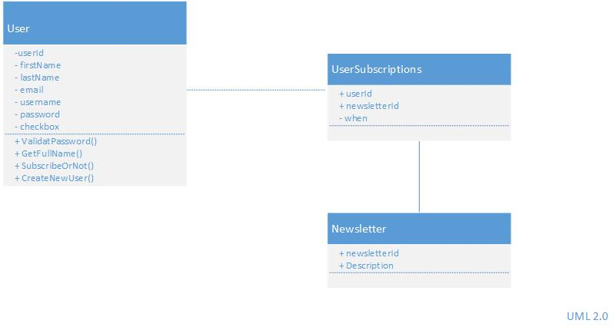

Entities
User: The User class represents both user and administrator. It is the base class for all users as well as a base for administrators to receive information and store it in the database. This class is responsible in managing the user personal information.
UserSubscription: The UserSubscription class will only have the responsibility to let the admin know which users want Newsletter subscriptions.
Newsletter: This class is a database entry with two field, newsletterId and the description of the Newsletter.

Data Design

One per module of the following:

Data Description

newsletter
From the above diagram, we identified a relationship between the user and their status on being subscribed. The possible types will be user and Administrator. The relationship “hasSubscribed” will also include an attribute to determine when the user subscribed, their subscriptionId, and their userId. The Newsletter will have attributes such as the newsletterId and the description of the Newsletter.
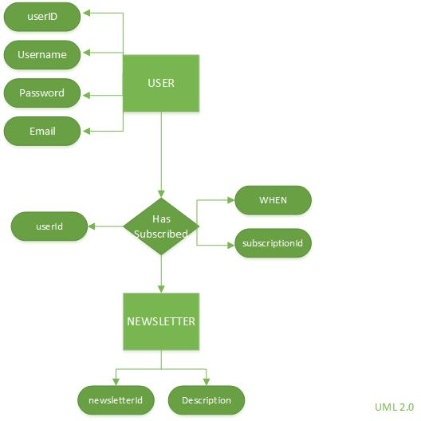

DATABASE Dictionary / SCHEMA

Newsletter
The following tables are defined for the News module, Newsletter module, and
User Table

Entity | Type | Value | Description
user_id | INT | Not null | PK. Unique identifier of a user.
user_type_id | INT | Not null | FK. Relationship key to the User_Types table
user_pw | varchar(20) | Not null | User’s password stored
first_name | varchar(30) | Not null | User’s first name
last_name | varchar(30) | Not null | User’s last name
Email | varchar(30) | Not null | User’s E-mail address

User_Types Table

Entity | Type | Value | Description
user_type_id | INT | Not Null | PK. Unique identifier of a user.
newsletter_type_id | INT | Not null | Newsletter Id
subscribed_type_when | INT | Not null | Date of subscription
type_desctiption | varchar(2000) | Not null | Newsletter description

Use Case: Configure Catalog
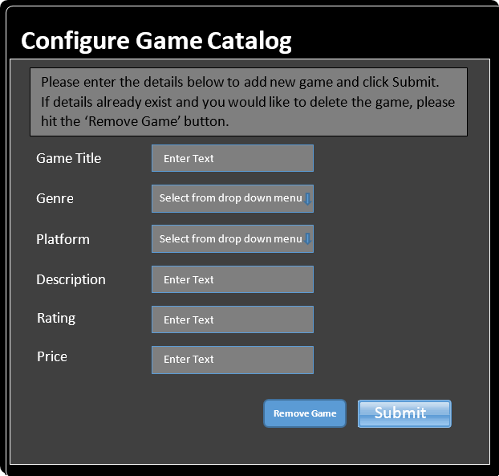

The ‘Configure Game Catalog’ page will allow the Administrator to add, remove or edit the games in the catalog. The Administrator must correctly enter all fields and hit submit or remove game.
INPUT & OUTPUT
INPUT:
Game Title: String that represents the title of the game. Minimum of 1 and maximum of 35 characters.
Genre: Dropdown list that represents the Genre of the game. Must select a genre out of the list.
Platform: Dropdown list that represents the Platform on which the game can run on. Must select one platform from the list.
Description: String that represents the brief description of the game. Minimum of 1 and maximum of 250 characters.
Rating: Number that represents the Rating the game has received. Must be out of 5.
Price: Number that represents the price of the game.
Submit: This button must be clicked in order to save changes.

OUPUT:
Once the Administrator enters all the information in the fields, the ‘submit’ button must be clicked. The game will then be added to the Game Catalog.
If the Administrator wants to simply edit the game, just update the fields and hit submit again.
If the Administrator wants to delete the game, then the ‘remove game’ must be clicked when this page is opened up via the Game Catalog while viewing the game.
Possible message:
“The game was added to the catalog!”
“The game was updated!”
“The game was deleted!”

ACTIONS:
When the administrator submits the form, the system validates to see if all the fields are properly filled in and if they are, it proceeds with entering or deleting the game from the catalog.
If the information is not valid (improper data or empty fields), the system will not process the information.

PRE AND POST CONDITIONS
Pre-Conditions: Must be logged into the system as an Administrator to edit the catalog.
Post-Conditions: The Administrator must save changes for the changes to appear by clicking submit or remove. The updated catalog will be visible to all users.

VALIDATION
Game Title, Description = These fields must be filled in and must follow the specified length. Cannot be too short or too long in length.
Genre, Platform = These fields contain the drop down menu. At least one selection must be made.
Ratings = Numeric field which must be within the limit of 1-5.
Price = Numeric field which contains the price. Must have a minimum and maximum number followed.

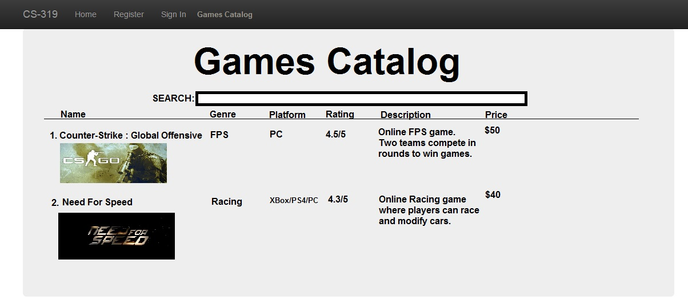
Use Case: View Catalog
The ‘Games Catalog’ page will allow the users to view the games which are stored in the catalog. They will be able to see the default list but will be allowed to search for their own game. The catalog shows different attributes such as Genre, Platform, Rating, Description and price for each game.
INPUT & OUTPUT
INPUT:
Search: The user can make a search and view the desired game and click it to view more details. The search must be a string and be valid.
Attribute Sort: The user will be able to sort the games by attributes such as Price, Ratings and Genres.
OUPUT: Once the user makes the search or views the catalog. The list will show up with all the games that are in the catalog.
ACTIONS:
When the user searches for their desired game, it must include a tag or keyword from the desired game or else the system will not show any games. If valid, the system processes the tags/keywords and brings up the search results. If the user has not searched, the default Games Catalog screen will be displayed with all our games.
PRE AND POST CONDITIONS
Pre-Conditions: The user must be logged in and must search for the games in order to see the results list. Otherwise, a featured default list of games will appear.
Post-Conditions: The users will be able to see the list of all the games that are under the filter applied during search.
VALIDATION
Search: The System will validate the search if it has proper tags and length of the string.

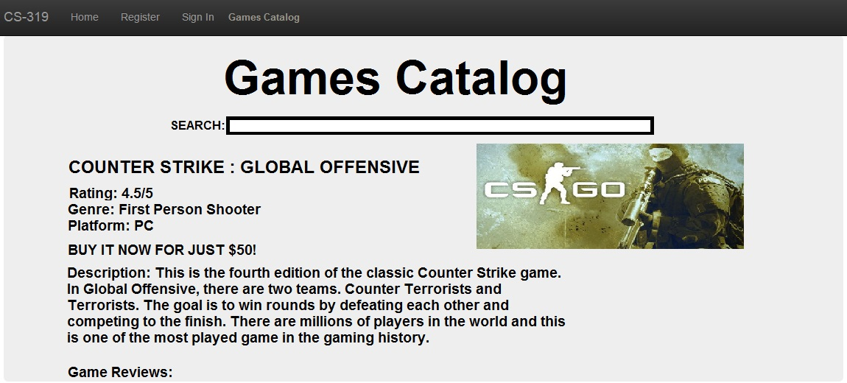
Use Case: View Details

The ‘View Details’ use case is the page that will appear once a user views the game catalog and wishes to view more details about the game. This page will show more details like a longer description, reviews and other things about the game.
INPUT & OUTPUT
INPUT:
User Selection: In order to view the details page, the user must click on a game from the Games Catalog page.
OUPUT:
Once the user makes the selection, they will be brought up with the detailed page of the game.
ACTIONS:
The user must be viewing the games catalog and once they click on the desired game, the system will process the request and bring up the page which shows details about the game such as a longer description, reviews and other things about the game.
PRE AND POST CONDITIONS
Pre-Conditions: The user must be logged in and must search for the games in order to see the results list. Once the list shows up, the user must click on a game to view the details page.
Post-Conditions: The users will be able to see the details of the game that they clicked on.
VALIDATION
Selection: User must click on a game.

Component Design
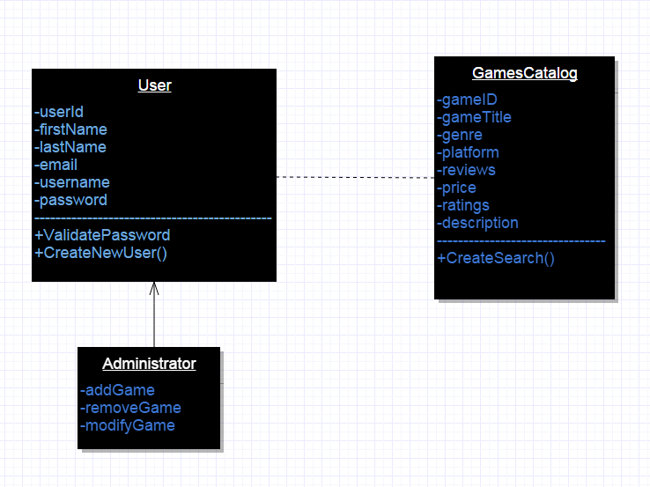

Entities

User: The User class represents the general user that will be using GameOn. It’s a base class that puts the general things in place such as the name, email, username and password of any user. It deals with the user’s information.
Administrator: This class is the child class of the User class. The Administrator is still a user but has extra rights such as adding or removing games from the Games Catalog.
Games Catalog: This class represents the Games Catalog. It has all the fields which will be used in the catalog. Fields such as game title, id, platform, genre and more.

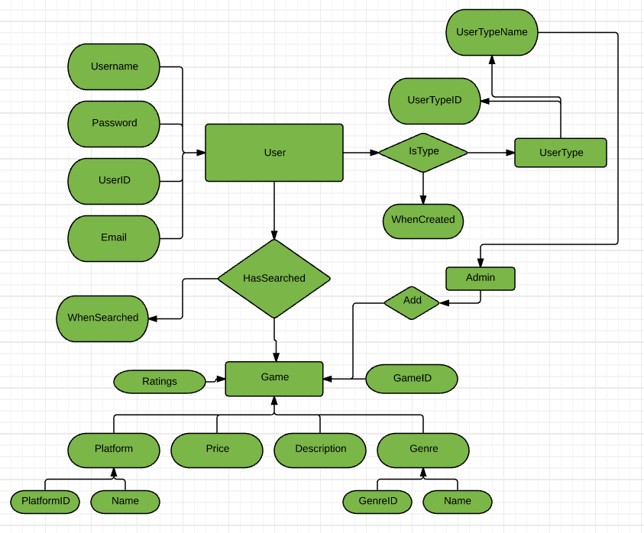
Data Design
This diagram shows the different relationship between a regular user and an administrator. It shows how the User base class has all the personal information of all users but there are different types of users that differ such as an Admin. The administrator will be able to add games into the catalog.
Once a user has searched the catalog, they will be shown the desired games. Game consists of multiple parts such as Platform, Price, Description, Genre and more. Some include child objects also such as ID’s and name of platform and genre.

Games Catalog
User Table

Entity | Type | Value | Description
user_id | INT | Not null | PK. Unique identifier of a user.
user_name | varchar(50) | Not null | User’s login username
user_pw | varchar(50) | Not null | User’s password HASH
first_name | varchar(30) | Not null | User’s first name
last_name | varchar(30) | Not null | User’s last name
Email | varchar(50) | Not null | User’s E-mail address

GamesCatalog table

Entity | Type | Value | Description
game_id | INT | Not null | PK. Unique identifier of a game.
game_title | varchar(50) | Not null | Title of the game
game_genre | varchar(50) | Not null | Genre of the game
game_rating | varchar(30) | Not null | Rating of the game
game_platform | varchar(30) | Not null | Platform the game runs on
game_reviews | varchar(50) | Not null | Reviews of the game
game_description | varchar(200) | Not null | Brief description of the game
game_price | INT | Not null | The price of the game

Search News Articles
NEWS
Search…

NEWS
Call of Duty

NEWS

Call of Duty: Black Ops 3 will let you create your own mods and maps on PC

Buy two get one free on all video games at Target next week
Amazon starts the Black Friday countdown with new deals every day

Call of Duty
NEWS
Call of Duty: Black Ops 3 will let you create your own mods and maps on PC

Search…

Treyarch has announced that the PC version of Call of Duty: Black Ops 3 will be getting both modding and mapping tools in 2016.

The new features will let players create their own maps as we all know how important a map is in a video game tool. I mean, when was the last time you played a video game without a map? If you did, the whole time, you were probably like “Duh, I totally wish I could make my own map of the game.”
And then to top it off, how many times have you said to yourself “Man, self, I would totally mod this piece.” Well, now you can, amigo. Now you can. Sit back and prepare to let yourself introduce new weapons, new enemies, new anything. Don’t dream it. Be it.
We applaud you CoD:BO3. We applaud you.

The news page will allow registered users to read articles that interest them related to the games that they want to read about. A customer inputs the search criteria. An initial page will show all headlines sorted newest stories first. A user must select a headline to retrieve the article related to the headline teaser.

INPUT & OUTPUT

Input:
- Headline Selection: User selects the headline by selecting or “clicking” a head line that appeals to their interest.

Output:
Upon successful credential check, the system will display a news article. In addition, if the user account data entered is invalid, the system will show a log in page.

Actions
Upon clicking a link, the system will validate that the user’s credentials are valid.
If the validation is successful, the system will run a query to retrieve the requested news article from the database.
If the validation failed, the system will abort transaction and redirect the user to the log in screen.

Pre and Post Conditions
Pre-conditions: User has registered with the system already, and is logged in.
Post-conditions: A news article is displayed.

Validation
The following validations will be performed on the submitted data:
- Username: Must match database record.
- Password: Must match database record.

Component Design
User
- (PK)UserID
- firstName
- lastName
- email
-username
- password
- creationDate
- -----------------------
+getUserName()
+getCustomerId()
+getCreationDate()
NewsArticle
- (PK)ArticleID
- ArticleHeadline
- ArticleText
- ----------------------
+getArticleId()
+getArticleHeadline()
+getArticleText()

Entities
Customer: The User class represents any person who registers with the GameOn service to take part in the benefits of our wonderful site. It is the base class below administrator. A customer would be the general user browsing news articles.
NewsArticle: Database entry with three fields: a unique ArticleID, an article headline, and the article text.

Data Design

Data Description

Registration / Authentication
From the above diagram, we identified a relationship between a customer and a news article. A customer must be logged into the system with valid credentials to be displayed a news article text content.
A news article consists of three parts: a unique article id, a headline, and the article text.

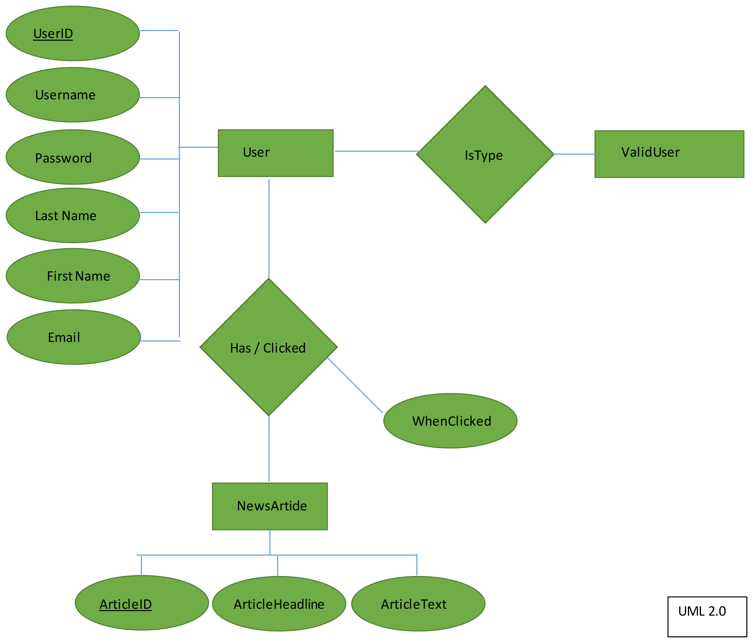

DATABASE Dictionary / SCHEMA

News
The following tables are defined for the news module
NewsArticle Table

Entity | Type | Value | Description
ArticleID | INT | Not null | PK. Unique identifier of a user.
ArticleHeadline | varchar(200) | Not null | Brief article headline
ArticleText | varchar(2000) | Not null | Article text

User Table

Entity | Type | Value | Description
UserID | INT | Not null | PK. Unique identifier of a user.
UserName | varchar(50) | Not null | Name user picks to be known as within the site.
Password | varchar(50) | Not null | Secret, unique password to provide security.
LastName | Varchar(50) | Not null | Customer’s last name.
FirstName | Varchar(50) | Not null | Customer’s first name.
Email | Varchar(200) | Not null | Current email address.

Post/Upload Articles (For Administrators)

Input article text…
ARTICLE UPLOAD
Input article headline…
UPLOAD
ARTICLE UPLOADED!
CONTINUE

The upload page allows an administrator to easily select a file to upload to the news article database. An admin is presented with a browse screen. The admin browses to the file location and selects the upload button. A confirmation page is displayed upon a successful upload.

INPUT & OUTPUT

Input:
- Admin inputs text to upload into the GameOn article database.

Output:
Upon successful article upload, the system will display a success banner.

Actions
Upon uploading an article, the system will validate that the admin’s credentials are valid.
If the validation is successful, the system will upload the news article to the database.
If the validation failed, the system will abort transaction and redirect the user to the log in screen.

Pre and Post Conditions
Pre-conditions: Admin has registered with the system already, and is logged in.
Post-conditions: A confirmation page is displayed.

Validation
The following validations will be performed on the submitted data:
- User Type: User must be an admin.
- Password: Must match database record.

Component Design
Admin
- (PK)AdminID
- (FK)CustomerID
- DateCreated
- -----------------------
- postNewsArticle()

NewsArticle
- (PK)ArticleID
- ArticleHeadline
- ArticleText
- --------------------------------
- isType()

Entities
Admin: An “admin” is an abbreviation for administrator. An admin is a customer with elevated privileges such as posting and editing new articles.
NewsArticle: Database entry with three fields: a unique ArticleID, an article headline, and the article text.

Data Design

Data Description

Article Upload
From the above diagram, we identified a relationship between an admin and a news article. An admin must be logged into the system with valid credentials to upload a news article.
A news article consists of three parts: a unique article id, a headline, and the article text.

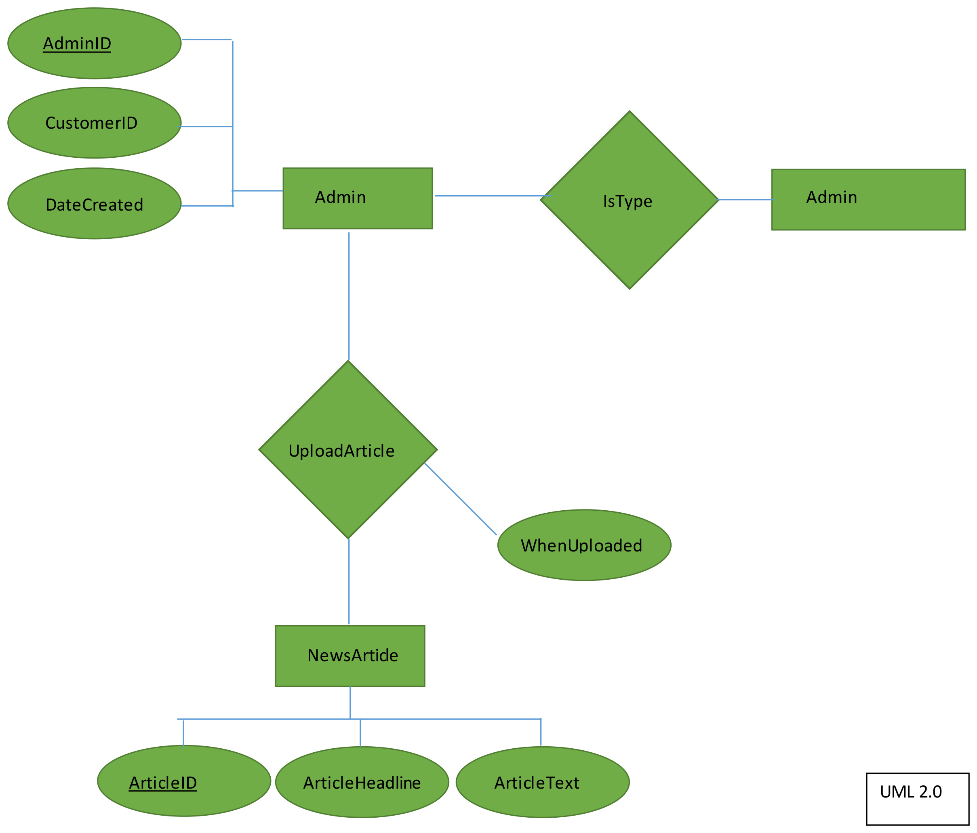

DATABASE Dictionary / SCHEMA

Post News Article
The following tables are defined for the news module
NewsArticle Table

Entity | Type | Value | Description
ArticleID | INT | Not null | PK. Unique identifier of a user.
ArticleHeadline | varchar(200) | Not null | Brief article headline
ArticleText | varchar(2000) | Not null | Article text

Admin Table

Entity | Type | Value | Description
AdminID | INT | Not null | PK. Unique identifier of a user.
CustomerID | INT | Not null | FK. ID number of customer/admin relationship.
DateCreated | DATE | Not null | Date of Admin account creation.

Edit Articles (For Administrators)

ARTICLE EDIT
Search for article…
SEARCH

RESULTS

Article Result 1
Article Result 2
Article Result 3
Article Result 4
Article Result 5
Article Result 6
Article Result 7
Article Result 8

A new Grand Theft Auto game has been hinted! Developers at a recent conference unveiled the new game which was referred to as “revolutionary” and “ground breaking.”
EDIT ARTICLE
New Grand Theft Auto Game!
REVISE

ARTICLE EDITED!
CONTINUE

The edit page allows an administrator to easily change a file to fix minor errors. An admin is presented with a search screen. The admin browses to the correct file location and selects the headline. An edit page is displayed. Once article is revised, a success banner is displayed.

INPUT & OUTPUT

Input:
- Admin inputs text to upload into the GameOn article database.

Output:
Upon successful article upload, the system will display a success banner.

Actions
Upon uploading an article, the system will validate that the admin’s credentials are valid.
If the validation is successful, the system will upload the news article to the database.
If the validation failed, the system will abort transaction and redirect the user to the log in screen.

Pre and Post Conditions
Pre-conditions: Admin has registered with the system already, and is logged in.
Post-conditions: A confirmation page is displayed.

Validation
The following validations will be performed on the submitted data:
- User Type: User must be an admin.
- Password: Must match database record.

Component Design
Admin
- (PK)AdminID
- (FK)CustomerID
- DateCreated
- -----------------------
- editArticle()

NewsArticle
- (PK)ArticleID
- ArticleHeadline
- ArticleText
- --------------------
- isType()

Entities
Admin: The User class represents any person who registers with the GameOn service to take part in the benefits of our wonderful site. It is the base class below administrator. A customer would be the general user browsing news articles.
NewsArticle: Database entry with three fields: a unique ArticleID, an article headline, and the article text.

Data Design

Data Description

Article Upload
From the above diagram, we identified a relationship between an admin and a news article. An admin must be logged into the system with valid credentials to upload a news article.
A news article consists of three parts: a unique article id, a headline, and the article text.
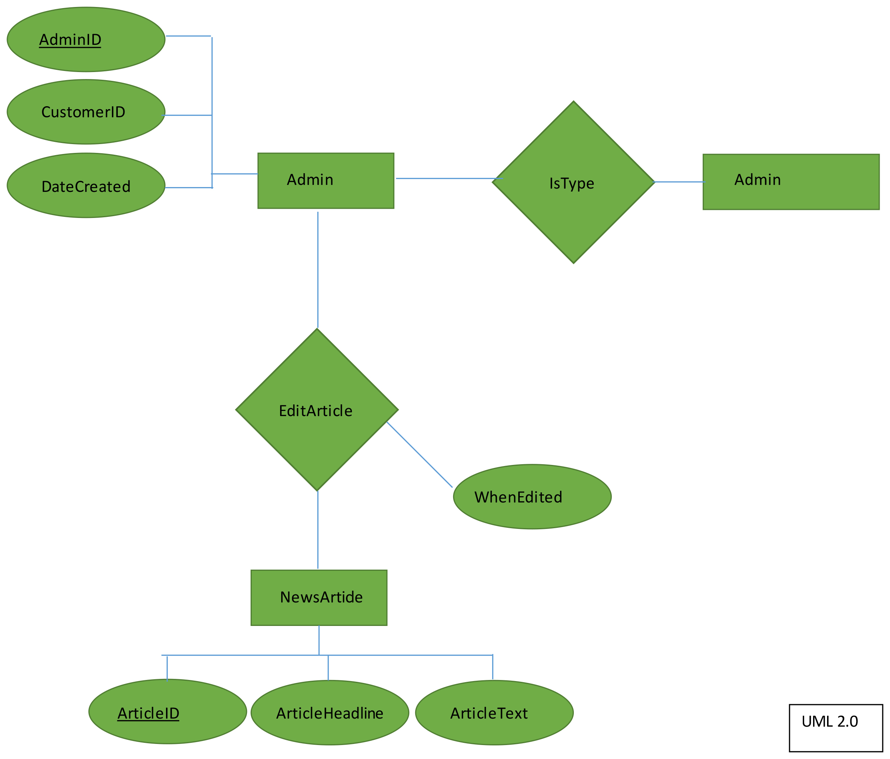

DATABASE Dictionary / SCHEMA

Edit News Article
The following tables are defined for the edit news module
NewsArticle Table

Entity | Type | Value | Description
ArticleID | INT | Not null | PK. Unique identifier of a user.
ArticleHeadline | varchar(200) | Not null | Brief article headline
ArticleText | varchar(2000) | Not null | Article text

Admin Table

Entity | Type | Value | Description
AdminID | INT | Not null | PK. Unique identifier of a user.
CustomerID | INT | Not null | FK. ID number of customer/admin relationship.
DateCreated | DATE | Not null | Date of Admin account creation.

Full DAtabase Model
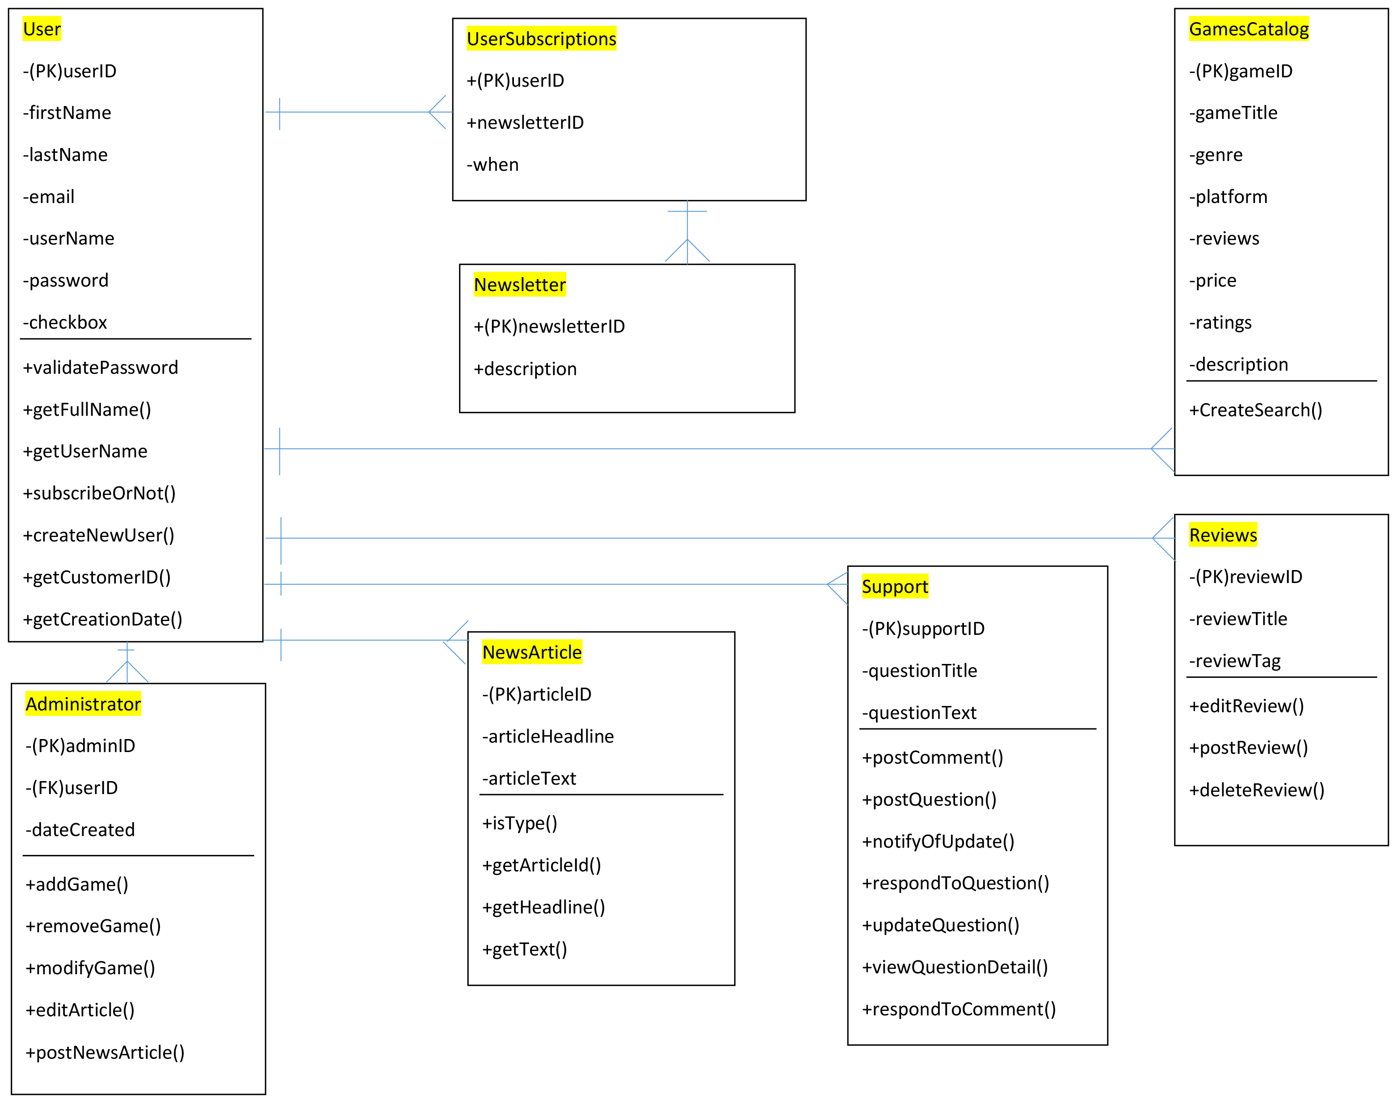

Requirements Matrix

Module | Use Case | Design Component
Newsletter Module | Registration | User Interface: Register and subscribe  ERD Diagram 1  Component Model: Registration  DB Schema section1
 | Create Newsletter | User Interface: Create Newsletr  ERD Diagram 1  Component Model: Create Newsletter  DB Schema section1
 | Edit Newsletter | User Interface: Edit Newsletr  ERD Diagram 1  Component Model: Edit Newsletter  DB Schema section1
 | Preview Newsletter | User Interface: Preview Newsletter  ERD Diagram 1  Component Model: Preview Newsletter  DB Schema section1
Games Catalog | Configure Catalog | User Interface: Configure Catalog  ERD Diagram 2  Component Model: Configure Catalog  DB Schema section2
 | View Catalog | User Interface: View Catalog  ERD Diagram 2  Component Model: View Catalog  DB Schema section2
 | View Details | User Interface: View Details  ERD Diagram 2  Component Model: View Details  DB Schema section2
News | Browse Articles | User Interface: Browse Articles  ERD Diagram 3  Component Model: Browse Articles  DB Schema section3
 | Post Articles | User Interface: Post Articles  ERD Diagram 3  Component Model: Post Articles  DB Schema section3
 | Edit Articles | User Interface: Edit Articles  ERD Diagram 3  Component Model: Edit Articles  DB Schema section3
 | Define Articles | User Interface: Define Articles  ERD Diagram 3  Component Model: Define Articles  DB Schema section3

